Circle Language Spec: Commands

Public Inactive Clause = Command Out Parameter in a Diagram
The article Public Inactive Clause = Command Out Parameter conceptually explained the idea of public inactive clauses. The current article further demonstrates the idea using diagrams.

Active clauses, command calls and active command references in parent commands are always private, because you can not reference a sub-command (see the article Sub-Commands Are Never Referenced).

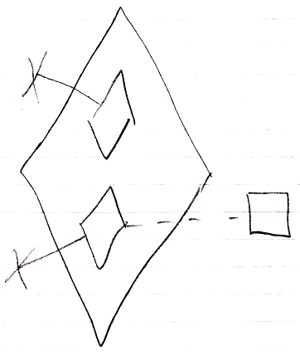

But inactive clauses can be referenced might be made public.

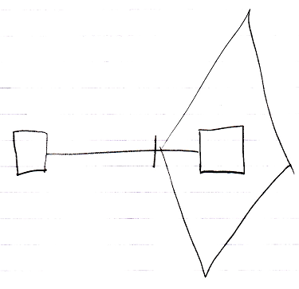

If you make an inactive clause public, you will make it an Object Out parameter: an object produced by the command.

